Technical Architecture Design Specification
FOR
Volunteer Management System
(VMS)

CLIENT
PROJECT | Volunteer Management System (VMS)Volunteer Management System
TITLE | Technical Architecture Design Specification
VERSION | 0.1a
DATE | 28-Feb-2011
 | ORIGINATOR
 | Name / Signature | Team 8S
 | APPROVAL
 | Name / Signature | Phung Kim Cuong, Dio
Institute of Systems Science |  | Document Reference
25 Heng Mui Keng Terrence  Singapore 119615 |  | VMS/T-1.5.1/1

 | Acceptance
 | Customer Signature |  | Customer Signature
 | Name & Designation |  | Name & Designation
 | Date & Company Stamp |  | Date & Company Stamp

Revision History

Date | Version | Description | Author
28-Feb-2011 | 0.1 | Creation | Team 8S
 |  | Refer to amendment history

Table of Contents

1. Document Overview 3
1.1 Target Audience 3
2. High Level Application Architecture 4
2.1 Application Architecture Overview 4
3. Technologies & Tools 4
3.1 Client 5
3.2 Web Layer 5
3.3 Middle Tier 5
3.4 Data Persistence 5
4. Project Development Structure 6
4.1 Design of Modules 6
4.2 Development Tools Configuration 6
4.3 Development Environment 6
5. User Interface Design Guidelines 6
5.1 Naming Convention 6
5.2 Sequence Diagrams 6
6. Middle Tier (Spring) 6
6.1 Controller Design 6
6.2 Business Delegate 6
6.3 SMTP Utility 6
7. Persistence 6
7.1 Static Structure 7
7.2 Dynamic Interactions 7
7.3 Naming Convention 9
7.4 Standards 9
8. Reporting Utility 9
8.1 Static Structure 9
8.2 Dynamic Interactions 10
9. Others 10
9.1 J2EE Packaging 10
9.2 Build Configuration 10
9.3 Other Configurations 10
9.4 Java Naming Convention 10
ANNEX D Amendment History 12

Document Overview
This document describes the high level design architecture for the VMS application’s components and development patterns adopted. VMS system (hereby refer to as system) is used by the NGO staff and volunteers and is designed as a public web based application.

Target Audience
The intended readers of this document are:
- the development team, to provide them with a high level design of the system and high level standards and guidelines for the development of the system.

High Level Application Architecture

Application Architecture Overview
The following depicts the requirements functionalities that reside in the system.
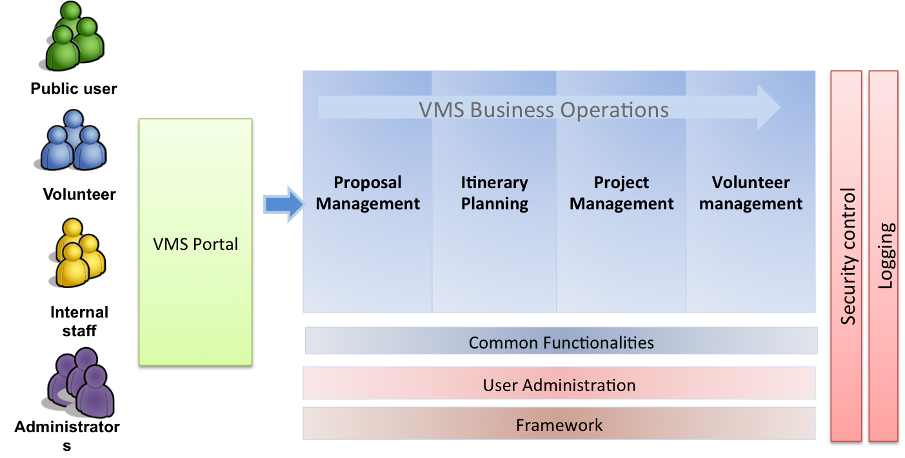

Figure 1 – Logical Application Diagram

Technologies & Tools
The following diagram depicts the technologies and tools used for this system.
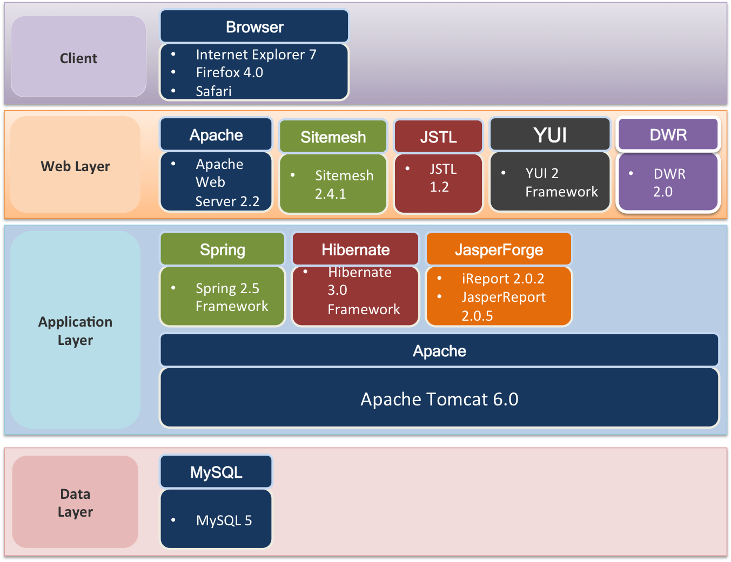

Figure 2 – Overview of Technologies & Tools

Client
The system will support the Internet Explorer 7, Firefox 4 and Safari 5.

Web Layer
The front end web tier layer will be handling the .

Middle Tier
The following depicts the requirements functionalities that reside in the system.

Data Persistence
The following depicts the requirements functionalities that reside in the system.

Project Development Structure

Design of Modules
This section discuss about the segregation of modules. Defining the frontend, backend and helper classes.

Development Tools Configuration
This section defines the configuration required for the development tools that are used for the system. Such as how eclipse is configured, etc.

Development Environment
This section defines the development environment, such as how many dbs?.

User Interface Design Guidelines

Naming Convention
This section discuss about the segregation of modules. Defining the frontend, backend and helper classes.

Sequence Diagrams
This section include jsp, custom tags, authentication, authorisation, how you want to code your jsp? How to name jsp, header, footer.

Middle Tier (Spring)

Controller Design
This section discuss about the segregation of modules. Defining the frontend, backend and helper classes.

Business Delegate
This section defines the business.

SMTP Utility
This section defines the development environment.

Persistence
The persistence for the VMS system is built based on Hibernate. Hibernate enables Application to access data from any database in a platform-independent manner. There is no need for the Application to depend on the low-level JDBC details like managing connection, dealing with statements and result sets. All the necessary details for accessing a particular data source is easily configurable in Xml files.
One of the issue with using Hibernate is that the client Application that accesses the database using Hibernate Framework has to depend on the Hibernate APIs like Configuration, SessionFactory and Session. These objects will continue to get scattered across the code throughout the Application. Moreover, the Application code has to manually maintain and manage these objects. In the case of Spring, the business objects can be highly configurable with the help of IOC Container. In simple words, the state of an object can be externalized from the Application code. It means that now it is possible to use the Hibernate objects as Spring Beans and they can enjoy all the facilities that Spring provides.
The details of DAO method design would be left to the programmer.

Static Structure
The following class diagram illustrates the static structure of the design.
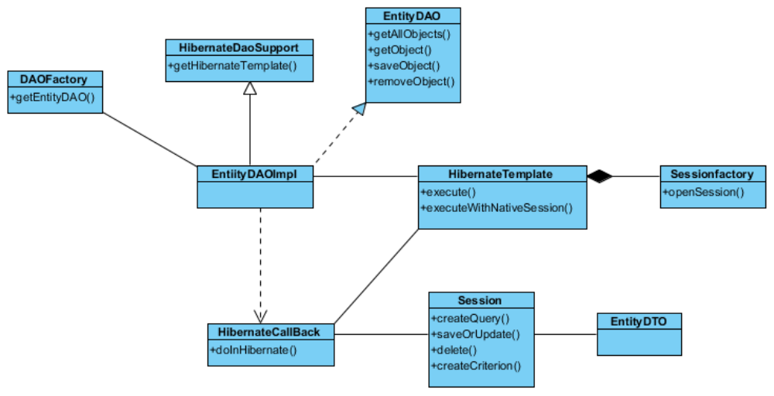

Figure 3 – Static Structure

Dynamic Interactions
The following sets of dynamic interactions are supported for each persistent entity object.
- Instantiation of a DAO
- Traversal of all the DTOs (including retrieval of the values of the attributes of the DTOs)
- Addition and Modification of a DTO
- Removal of a DTO

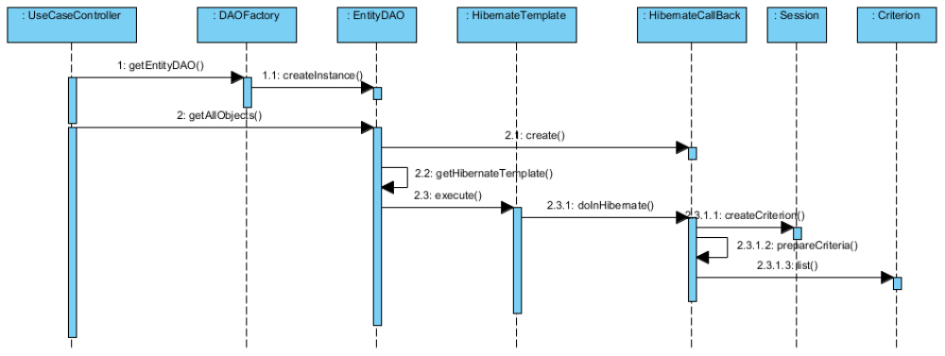

Figure 4 – Instantiation of DAO

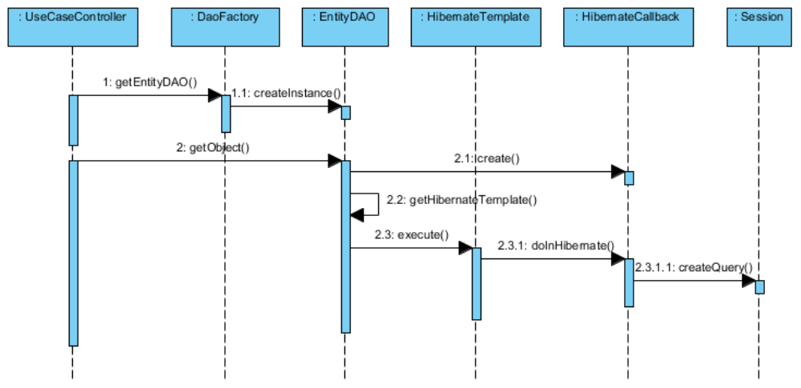

Figure 5 – Instantiation of DAO

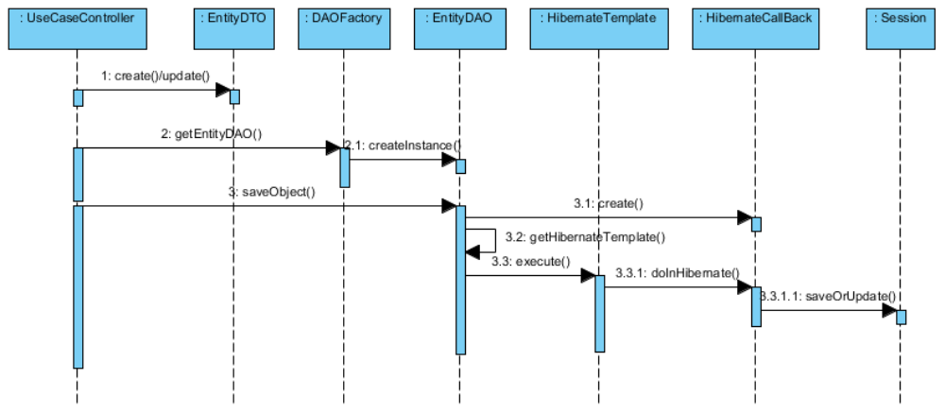

Figure 6 – Addition/Modification of DTO

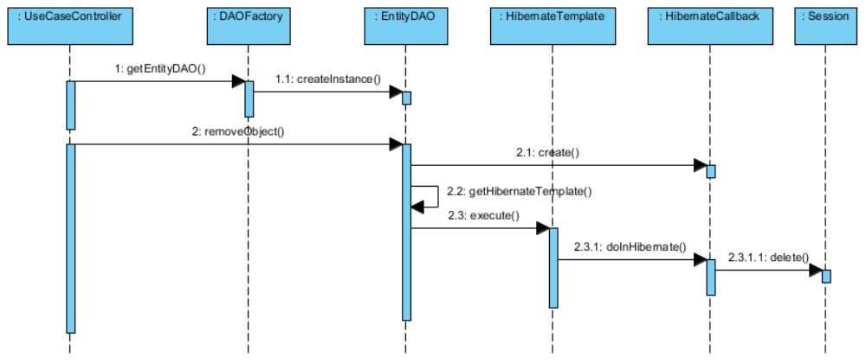

Figure 7 – Deletion of DTO

XML Configuration
This section deals with configuring the various information needed for the Spring Framework. In Spring, all the business objects are configured in Xml file as Spring Beans. These Spring Beans are maintained by the IOC which is given to the Client Application upon request. The hibernate-Spring bean mapping is defined as follows:
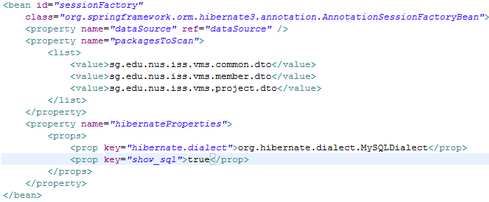
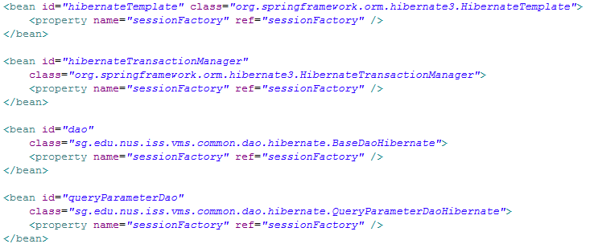

Table 1 – Hibernate XML Configuration
Since the annotations will be used instead of hibernate mapping files, the first bean defines type 'org.springframework.orm.hibernate3.annotation.AnnotationSessionFactoryBean’. AnnotationSessionFactoryBean.
The 2rd important Spring Bean is the Hibernate Template. It provides a wrapper for low-level data accessing and manipulation. Precisely, it contains methods for inserting/deleting/updating/finding data in the database. For the Hibernate Template to get configured, the only argument is the SessionFactory object as represented in the following section.

Naming Convention
This section defines the naming convention for the xml files and maps used for Hibernate.
Blah blah blah..

Standards
One module will contain one DAO object, unless it is a complex or many functions are residing within one module, and then multiple DAO objects will be created. The complexity level of a module will be left to the designer to decide.

Reporting Utility

Static Structure
The following class diagram illustrates the static structure of the design.

Figure 8 – Static Structure

Dynamic Interactions
The following sets of dynamic interactions are supported for each persistent entity object.
- Instantiation of a DAO
- Traversal of all the DTOs (including retrieval of the values of the attributes of the DTOs)
- Addition and Modification of a DTO
- Removal of a DTO

Figure 9 – Instantiation of DAO

Others

J2EE Packaging
This section discuss about the segregation of modules. Defining the frontend, backend and helper classes.

Build Configuration
This section defines the .

Other Configurations
This section discuss about all other configurations used for the system.

Spring Configuration
- spring-controller-vms.xml to configure all the business logic beans/ page beans and dwr beans
- spring-hibernate-vms.xml to configure hibernate session factory
- spring-security.xml to configure the spring security interceptor

Email Configuration
Email configuration file (cfg-mail.properties) is to set email user that vms will be use to send email alert as follow.

sys.server.mail.send.host=vms.com.sg
sys.server.mail.send.username=volunteers
sys.server.mail.send.password=user123
sys.server.mail.send.port=25

sys.server.mail.receive.host=vms.com.sg
sys.server.mail.receive.username= volunteers
sys.server.mail.receive.password=user123
sys.server.mail.receive.port=110

Database Configuration
cfg-database.properties is to configure the database connection parameters such as JNDI, number of cached statements, timeout of pool connection and validation SQL. The logger will save the information into the file and file will be splitted into different file based on the file format
(“vms .log.2011-03-25.log”).

Logger Configuration
log4j.properties file can be found under the src folder. The application log flag, log level and log location configuration can be configured.
# Direct log messages to stdout
log4j.appender.stdout=org.apache.log4j.ConsoleAppender
log4j.appender.stdout.Target=System.out
log4j.appender.stdout.layout=org.apache.log4j.PatternLayout
log4j.appender.stdout.layout.ConversionPattern=[VMS] %d [%-5p] [%t] %c.%M(%-L) | %m%n

# Root logger option
#log4j.rootLogger=INFO, stdout
log4j.logger.org.springframework=ERROR
#log4j.rootCategory=error, stdout, R
log4j.rootCategory=DEBUG, stdout, R
log4j.appender.R=org.apache.log4j.RollingFileAppender
log4j.appender.R.File=logs/vms.log
log4j.appender.R.MaxFileSize=10000KB

#detail log filter
log4j.logger.mtech.se1008s.service.DispatcherServlet=ERROR

Java Naming Convention
This section defines the naming conventions that will be used for the design and implementation.

Package
All packages shall be prefixed with: sg.edu.nus.iss.vms. Further subdivision is up to the individual programmer. In the case of common code, reusable components shall be placed within a package named according to the component, such as sg.edu.nus.iss.vms.common.

Class and Interface
- Class names shall be nouns, not verbs. Eg. Staff, Project
- Interface names shall be be an adjective (wherever possible) describing the enforced behaviors of the class. Preferably, interface names end in "able" following an emerging preference in Java. i.e. Clonable, Versionable, Taggable, etc.
- Class, and interface names shall begin with an uppercase letter, and shall not be pluralized unless it is a collection class.

Method
Method names are typically verbs. However they can also include nouns for example accessor methods (getter and setter). The following table describes the naming convention for method.
Accessor Type | Naming Convention | Example
Create | createXXX | createProject
Retrieve | getXXX | getProject
Update | updateXXX | updateProject
Delete | deleteXXX | deleteProject

Table 2 – Method
If the method is an accessor method, use a noun appropriate to the information that is returned, i.e.
public Project getProject()
public void setProject(Project project)

When accessing a collection class or an array, it is recommended to use pluralized noun for clarification, i.e:

public ArrayList<Event> getEventList()
public void setEventList(ArrayList<Event> )
public Project[] getProjects()
public void setProjects(Project[])

Attribute and Local Variable
Variable names shall follow the camel case convention. They shall begin with a lowercase letter. The initial letter of any subsequent words in the name is capitalized, and underscores are not used to separate words (or scope variables). Attributes that are not collections should not be pluralized. Eg. approvalName

Class & UI Naming Convention
Class Type | Naming Convention | Example
Boundary – Page | createXXX | createProject  createEvent
 | viewXXX | viewProjectList  viewCalendar
 | updateXXX | updateProject
 | deleteXXX | deleteProject
Boundary – Elements | xxxButton | createButton  deleteButton
 | xxxLabel | xxxLabel
Control | XXXController | MainController, ProjectController
Service | XXXService | ProjectService
Service Implementation | XXXServiceImpl | ProjectServiceImpl
Data Access | XXXDAO | ProjectDAO
Entity | XXX | Project, Staff
Constants | XXX_YYYY | MINIMUM_WAGE

Table 3 – Class & UI Naming Convention Method

Documentation
The implementation code shall contain detailed documentation for classes, methods, and variables, written in Javadoc style as required by the Java coding standards. The overall guidelines to generate Javadoc include:
- Document all classes and methods
- Internal details need not be documented
- Methods that implement an interface need not provide javadoc comments, since the javadoc comments are included in the interface and will be referenced when javadoc executes.
- Each method shall include the @exception, @param, and @return javadoc tags where appropriate. Eg.

Acceptable
/**
* Method to check if proscribed operation is allowed for this object.
* This method is needed to provided some level of security on operations.
*
* @param action must be an operation that has registered itself with the object
* @return boolean true if the operation is allowed, false otherwise.
* @exception UnknownException exception is thrown when an operation that has not
* registered with the object is passed as a parameter.
*
*/
public boolean operationIsAllowed(Operation action) throws UnknownException
{
}

Table 4 – Acceptable Javadoc Syntax

Unacceptable (no Javadoc tag)
/**
* operation check takes an operation and returns true or false
*/
public boolean operationIsAllowed(Operation action) throws UnknownException
{
}

Table 5 – Acceptable Javadoc Syntax

ANNEX D Amendment History

This is a record of all amendments made to the Document.
Version | Chapter / Section | Page No | Notes of Amendments or Changes

